Kenwood TS-480/TS-590

**Aki Yoshida JA1NLX and Mark Anderson WB2SMK**

**1.0 GENERAL**

Both radios basically use same CAT command and have been widely used. This section will provide basic setup and useful information.

**Note**: In this section the TS-590SG is used as a example. The TS-590S and TS-480 series will work with the same settings as well.

## 2.0 SETUP

**2.1 Setup Radio Dialog Box**

This is a Setup Radio dialog box for the TS-590SG

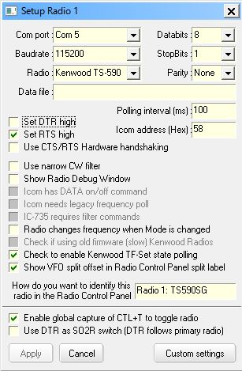

TS590_1

**Note**: There are two options to connect a PC and the TS590S for CAT control. One is to use a serial port and another is to use a USB port. If you want to use a USB port then you need to install a driver properly. See the operating manual. Baudrate is selected separately for each port in the TS-590S menu.

You need to check “Set DTR high” and/or “Set RTS high” depending on your system.

If you want to use $TF-Set$ and/or $mouseTF-Set$ macro then check “Check to enable Kenwood TF-Set state polling”.

**2.2 Setup in RCP (Radio Control Panel)**

**2.2.1 Macros configured in function buttons**

This is a sample macros configured in RCP Main.

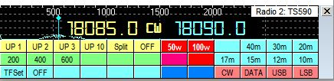

TS590_2

**Macro for UP 1**

$command FT0;FB#split+1#;FT1;$

$ClearCallsignOnQSYOff$

$ClearQSYMarker$

**Macro for 200 (Band width 200Hz)**

$command FW0200;$

**Macro for TF-SET**

$command TS1;EX06600001;FL2;$

**Macro for OFF (TF-SET OFF)**

$command TS0;EX06600000;FL1;$

$command FB;$

**2.2.2 Setup DX Spot Macros**

This is a sample macros configured in Setup DX Spot Macros table.

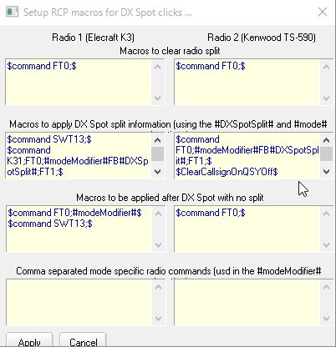

TS590_3

Here are details in Macros to apply DX Spot split information... box as it does not show all macros.

$command FT0;#modeModifier#FB#DXSpotSplit#;FT1;$

$ClearCallsignOnQSYOff$

$ClearQSYMarker$

**3.0 FREQUENCY AND MODE DISPLAYED IN RCP MAIN**

In this example VFO A is set to 18085 KHz CW and VFO B is set to 18090 KHz CW. “Show VFO A and VFO B side by side” option is checked.

* + **Simplex mode and VFO A is in use**

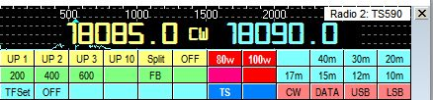

TS590_4

**Note**: VFO B mode is not displayed. This is normal.

* + **Simplex mode and VFO B is in use**

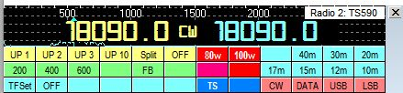

TS590_5

**Note**: VFO B freq/mode is displayed in left area and VFO B freq is displayed in right area.

* + **Split mode and VFO A is in use (VFO A for RX VFO B for TX)**

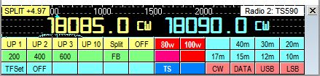

TS590_6

**Note**: VFO A freq/mode is displayed in left area and VFO B freq/mode is displayed in right area.

* + **Split mode and VFO A is in use. Hold TF-SET button. (this swaps VFO A and B)**

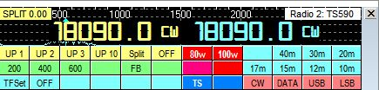

TS590_7

**Note**: VFO B freq/mode is displayed in both left and right area.

**3.1 Frequency and mode displayed in RCP SO2R**

In this example K3 is configured as Radio 1 and TS-590SG is configured as Radio 2.

* + **Radio 1 is primary radio. Radio 2 is in simplex mode**.

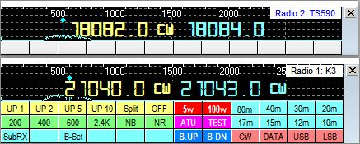

TS590_10

**Note**: VFO B mode is not displayed in RCP SO2R. This is normal.

* + **Radio 1 is primary radio. Radio 2 is in split mode**.

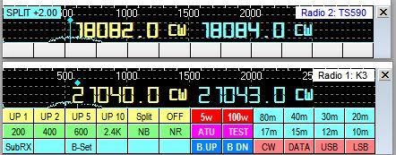

TS590_11

**4.0 HOW TO ADD AN EXTERNAL SUB-RECEIVER**

The TS-590SG/TS-590S/TS-480 have no internal sub receiver. This is a weak point in this great transceiver, however you may add external sub receiver. This is a example to add Elecraft K2 as external sub receiver for TS-590SG. The main purpose is to find frequency and make a call with TS-590SG and listen to DX station with K2 at the same time. Both radios should be in simplex mode (not split mode).

**4.1 Using Echo port**

This is described in Echo Port topic.

**4.2 Using K2 as Radio 2**

When you click DX spot or you turn TS-590SG VFO knob you must send specific command to K2 to be tuned to same frequency as TS-590SG. This command is configured in one of function buttons in RCP.

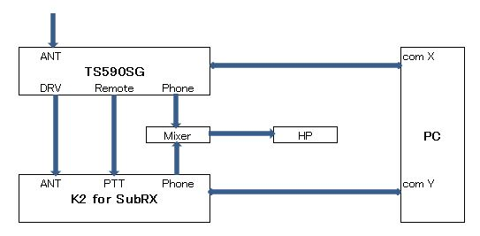

TS590_8

**Note**: This method is applicable for all transceivers.

### 4.3 Logger32 setup

* + **TS-590SG Setup**

TS-590SG is configured as Radio 1.

* + **K2 Setup**

K2 is configured as Radio 2.　See the Elecraft K2 K3 topic for details.

* + **RCP setup**

When you click DX spot with split comment then both radios should not turn in split mode. For this purpose “Enable Set Split Macro when clicking on a DX Spot” option should be unchecked. See TS590_11.

Following macro should be configured to send command to K2. This macro is to tune K2 to same frequency/mode as TS-590SG.

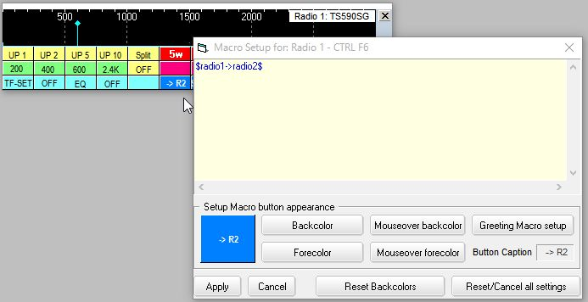

TS590_9

Logging frequencies are written depending on checked option in the Logging frequency setup table located in the Radio Control Panel. In the following example primary radio VFO-A frequency is written as FREQ and secondary radio VFO-A frequency is written as FREQ_RX in the Logbook.

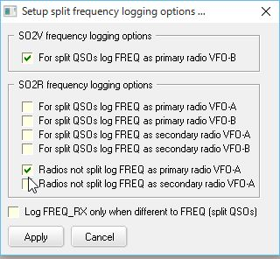

TS590_9A

**5.0 Using SDR with Kenwood TS-590SG as Panadapter/Second Receiver**

# 5.1 Goals

Primary - To add SDR support to my TS-590SG and to allow other applications to also access & control the rig.

These instructions do not cover the download/installation of any of the tools, only the process for configuring them to work together.

# 5.2 My Setup

I currently have the following items set up in my shack:

* Kenwood TS-590SG
* Logger32
* HDSDR
* JT-65 HF HB9HQX Edition
* WSJT-X
* Nooelec dongle (RTL2832) + Nooelec Up-converter
* VSPE – Virtual Serial Port Emulator
* Omni-Rig
* Windows 10 PC

I do not know how to accomplish this on Linux or Mac's - sorry!

# 5.3 Display spectrum via HDSDR

This lets you:

* See the full ham (or other!) band to see where the activity is – or isn’t.
* Identify file-ups or open areas for calling CQ
* Look for particular types of activity, e.g. JT65 vs. SSB vs. CW.

# 5.4 Link Frequency & Mode

The system connects the various elements to share the frequency and mode. This allows the SDR to provide a panoramic display of the spectrum space in use and links the rig to the SDR as well as JT-65, FT-8, and my logging program so that frequency and mode track between them all.

# 5.5 Settings

Each of the various elements in this system will require their own unique settings. These settings were derived based on many resources found on-line supplemented with my own experimentation. While it is possible that other combinations will work and perhaps be ‘better’, this set has at least worked for me.

With the righ and the SDR dongle plugged in, the Device Manager will show the two items seen COM3 is for the TS-590SG rig and the RTL2838UHIDIR is the Nooelec SDR dongle.

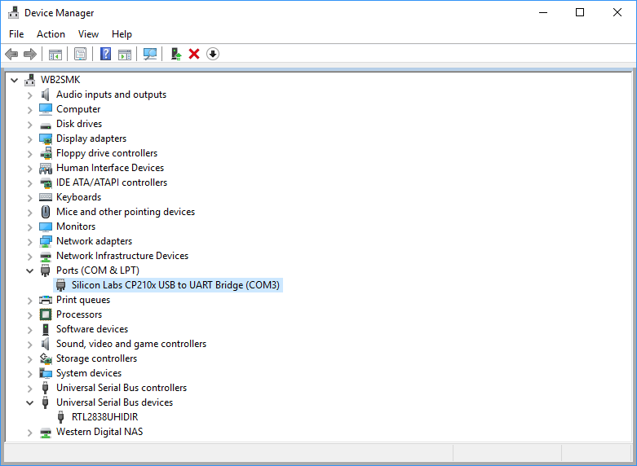

TS590_10

## Rig

All of this is easy to do because the TS-590SG supports an antenna output to drive a second receiver, which in this case is the SDR. On the rig, you must change Settings Menu 85 to set the DRV function to antenna. On other radios you would have to tap into the IF for a panoramic display or use a T/R switch to feed both the rig and the SDR in receive and feed the antenna directly to the rig for transmitting.

## VSPE

This package provides virtual serial ports and is currently a key component in this configuration. When starting up it will nag you to buy the 64 bit license but you do not need it. It will run fine in 32 bit (free) mode. Just click on “No” to the purchase offer then ok to the next window.

Create a “Splitter” to create a link to virtual port COM5 from physical port COM3. You may use / need to use other ports based on what's available in your PC.

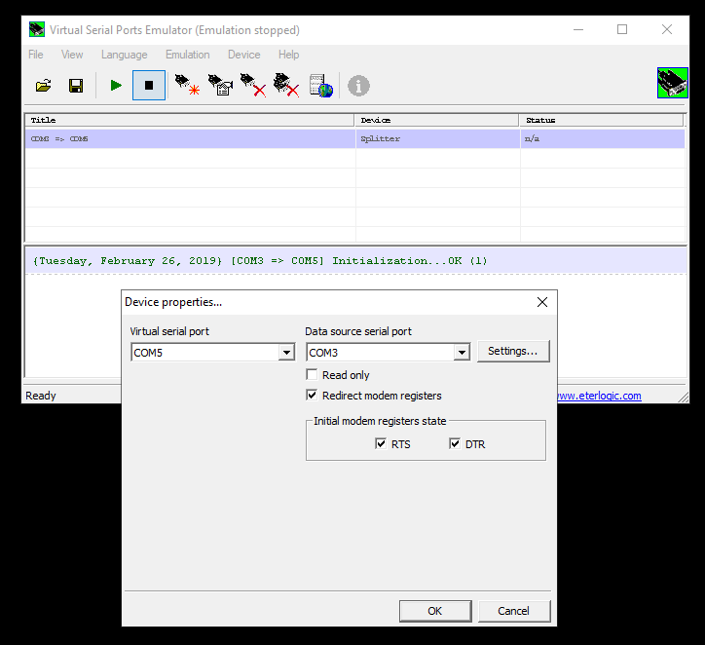

TS590_11

I found that I needed RTS/DTR to start in the "on" condition.

Next, go into the Setting button and enter the settings in Figure 2 - Serial Port Settings to match your rig's settings.

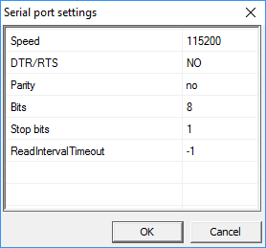

TS590_13

Note that the settings MUST include no DRT/RTS. I did not find any other combination of settings that worked!

Once configured, be sure to "Run" the configuration using the green arrow button.

Note that the virtual port COM5 does NOT show up in the Windows Device Manager port listing. Looking at the Hardware Manager reveals:

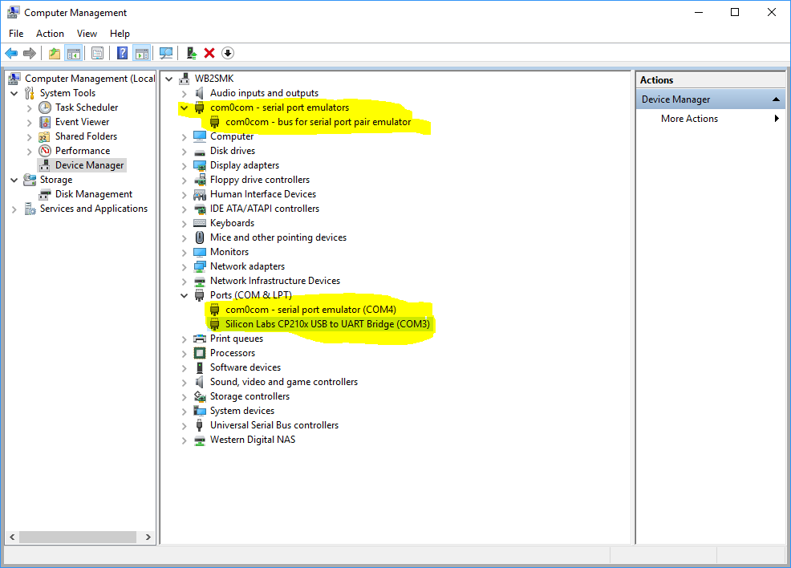

TS590_14

Note the following highlighted items:

1. There is an entry called com0com. This does NOT appear when VSPE is not running or when it is running but nothing is activated. If TWO of these show up, try deleting one. If that fails to get things working, reboot.
2. The rig shows up as COM3 in the Ports section. This should always be there at the same com port number and must match the VSPE configuration.
3. A com0com emulated port shows up in the Ports section.

Again, the emulated port created by VSPE does NOT show up anywhere in this display!

Note - you will have to start VSPE and start the serial port emulation every time your PC reboots! If your programs aren't tracking, be sure to check this first.

You can look at the serial port within VSPE using the information screen by clicking on the blue "i" button.

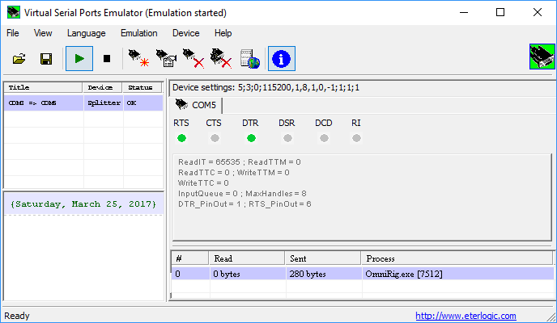

TS590_15

To make any configuration changes to the virtual serial port you must close all programs that might access the physical or virtual port, make the changes and then restart everything. Since I rarely reboot my PC, I have not found this to be a problem.

## HDSDR

This is one of the many available SDR programs that run with various SDR dongles. It supports the Nooelec dongle that I am using but the exact choice of dongle / SDR hardware should not matter. I preferred the user interface of HDSRD over the others and it works fine for me.

Set the SDR software to use OMNI-RIG. From Options menu choose “CAT to Radio (Omni-Rig)” then check the following items:

* sync Rig1
* sync to Omni-Rig
* sync from Omni-Rig
* sync Tune frequency
* sync Modulation

If HDSDR “loses” the RTL dongle, ZADIG may need to be re-run to re-install the WinUSB driver instead of the default RTL driver. The ZADIG tool is fully explained in the installation instructions for HDSDR.

## OMNI-RIG

The following settings can be made directly in Omni-Rig or this dialog can be opened from within HDSDR.

Set OMNI-RIG to be on COM5 (the virtual port created using VSPE), port parameters to match rig’s settings. For my rig, this is: 115,200 baud / 8 bits / no parity / 1 stop bit. Polling interval 500ms, timeout 4000ms as shown in . If you run into performance issues on your PC or your rig, just lower the polling speeds. It only introduces a slight delay when it updates the frequency and mode but does not affect overall operation.

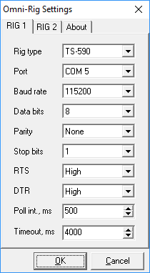

TS590_16

It appears that HDSDR uses the pmFreq definition from within the Omni-rig rig definition ini file while JT-65 requires that the pmFreqA ( or presumably pmFreqB) section be used. To resolve this conflict and to restore HDSDR’s ability to read/control the rig’s frequency, I modified the rig definition file. On my installation, this was found in: C:\Program Files (x86)\Afreet\OmniRig\Rigs\TS590.ini. I copied the entire file for a safe back up, then copied the commands from the pmFreqA section to the previously empty pmFreq section.

I have not made any other changes to this for the other programs that also work with this system.

Since I am not entirely clear on the inner details of Omni-Rig / HDSDR / JT-65 I am not sure exactly why this is needed nor, frankly, why it actually works!

## Logger32

Setup the rig to be on COM5 (the virtual port created using VSPE), port parameters to match rig’s settings. Again, for my rig, this is: 115,200 baud / 8 bits / no parity / 1 stop bit.

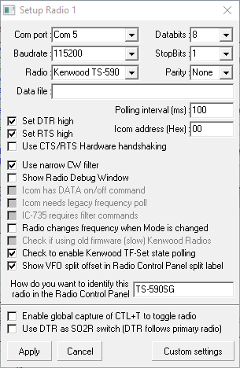

TS590_17

This JT-65 HB9HQX Edition supports an Omni-Rig connection. The Hamlib connection did not work when attempting to connect to the virtual com port.

The Omni-Rig configuration file dates back to 2011. Inside, it indicates that pmFreq is **not** supported and there are no commands configured! For this reason in JT-65 HB9HQX Edition, you must set the Omni-Rig’s Freq option to use pmFreqA so that it will use VFO A to control the rig’s frequency. Without that, JT-65 will properly display the rig’s frequency but is unable to set it. The other applications would still be able to change the rig’s frequency.

The Mode portion of the Omni-rig configuration may optionally be set to pmSSB_U which will automatically force the rig to upper sideband as needed for the JT-65 mode. A side effect of this is that the TS-590SG will send the Morse code indicator for that mode change – every time!

Unfortunately, putting the rig into SSB mode is not enough! One must also put it into DATA mode to pass the audio via the USB connector. To facilitate this and to add no interfere with the normal operation of pmSSB_U in case that’s ever needed, I modified the pmDATA_U entry in the rig definition file by changing the default entry to:

;--------------

; Mark Anderson WB2SMK; Make digital mode use USB but turn on DATA mode. I don't currently use direct FSK on the rig

; I had placed these commands in my Logger32 control panel so why not use them here too!

;$command LK00;$ lock OFF the front panel to make changes possibly not needed

;$command MD2;$ turn on USB

;$command FW2500;$ set filter to wide

;$command DA1;$ turn on DATA mode

;$command LK10;$ lock the front panel to avoid accidents

;$command AG0000;$ turn audio down to 0

;$command PC030;$ low power at 30 watts

; for this I ONLY need the actual command, not the $command prefix nor the $comment after it

;------------------

[pmDIG_U]

; personalized command string - more than just "mode"

Command=(LK00;MD2;FW2500;DA1;LK10;AG0000;PC030;)

ReplyLength=0

The overall configuration within JT65 can be seen in Figure 5 - JT65 Configuration. Note that this older version of Hamlib only has support for the TS-590S and not for the TS-590SG

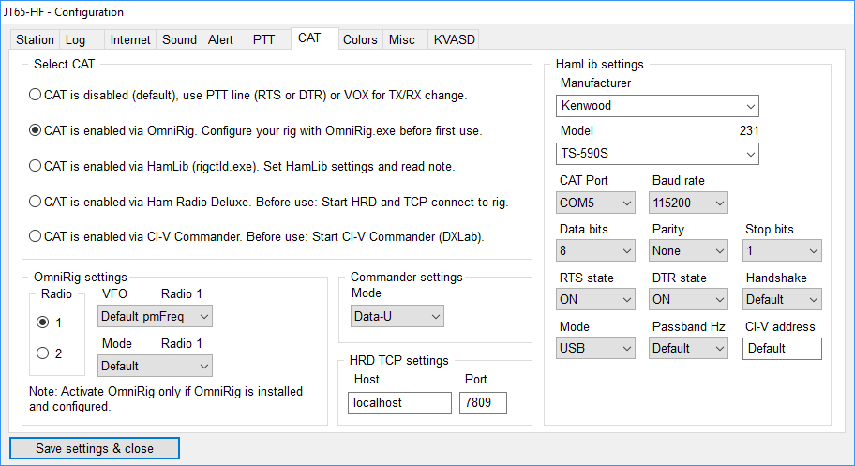

TS590_18

Selecting Omni-Rig provides the needed configuration page:

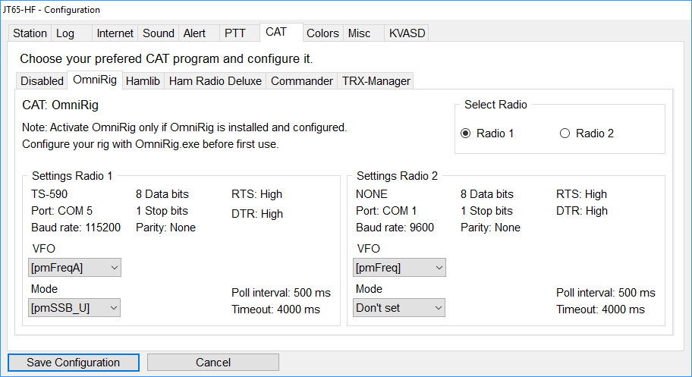

TS590_19

The PTT line must also be setup:

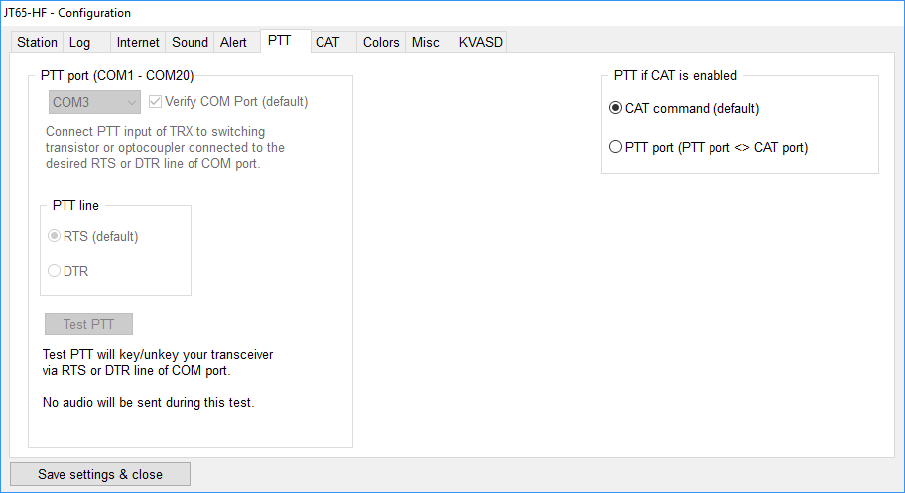

TS590_20

Note that this shows the manual edits to the rig definition file, e.g. Poll interval and Timeout.

## WSTJ-X

I have also added support for FT8 using the standard WSTJ-X package. Once the com port was set to also use COM5, the package was ready to go.

Other packages are likely to have very similar configuration details.

# 5.6 Physical Connections

The physical connections among the various pieces of hardware is straightforward:

* Ant -> rig -> DRV connector -> Up converter -> RTLSDR dongle -> PC USB port
* Rig -> PC USB port as COM3

This can be seen in Figure 11 - Physical Connections.

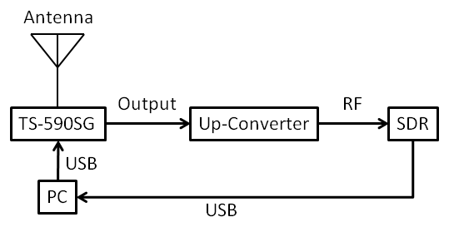

TS590_21

# 5.7 Resources

This working combination was achieved through the use of the following resources. My thanks to the various authors!

* <https://sites.google.com/site/g4zfqradio/installing-and-using-hdsdr>
* <http://www.crystalradio.us/projects/ts-590s-panadaptor.htm>
* <http://dxatlas.com/Download.asp> - for Omni-Rig
* <http://www.hdsdr.de/> - for HDSDR
* <http://www.eterlogic.com/Products.VSPE.html> - virtual serial port emulator
* <https://omniasdr.groups.io/g/main/topic/using_cat_with_a_logbook/2263174?p=,,,20,0,0,0::RecentPostDate%2FSticky,,,20,2,20,2263174>

*Created with the Personal Edition of HelpNDoc: [Single source CHM, PDF, DOC and HTML Help creation](http://www.helpndoc.com/help-authoring-tool)*